1 Instructions 1

2 Settings 1

The text search function will search all text fields in crm for containing the search text

The generated document will

1. Detail all record names and fields which contain the text
2. Append a record extract for any records with a matching name

Note the text search function uses the crm web services (which are not designed for this level of text searching) rather than custom indexed databases and will take a progressively longer amount of time for larger volumes of records

# Instructions

* Click the “CRM Record Text Search” option from the main menu
* Enter the save to folder, document format and search text then click next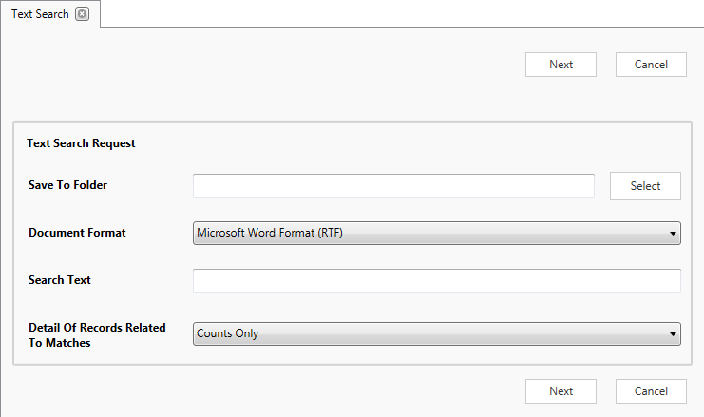
* Wait for the system to search through the text fields and generate a document outlining any matches in the system

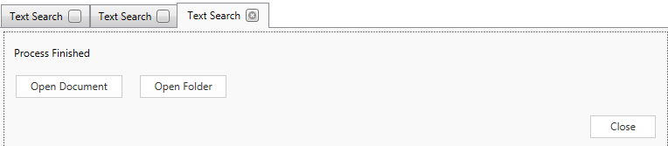

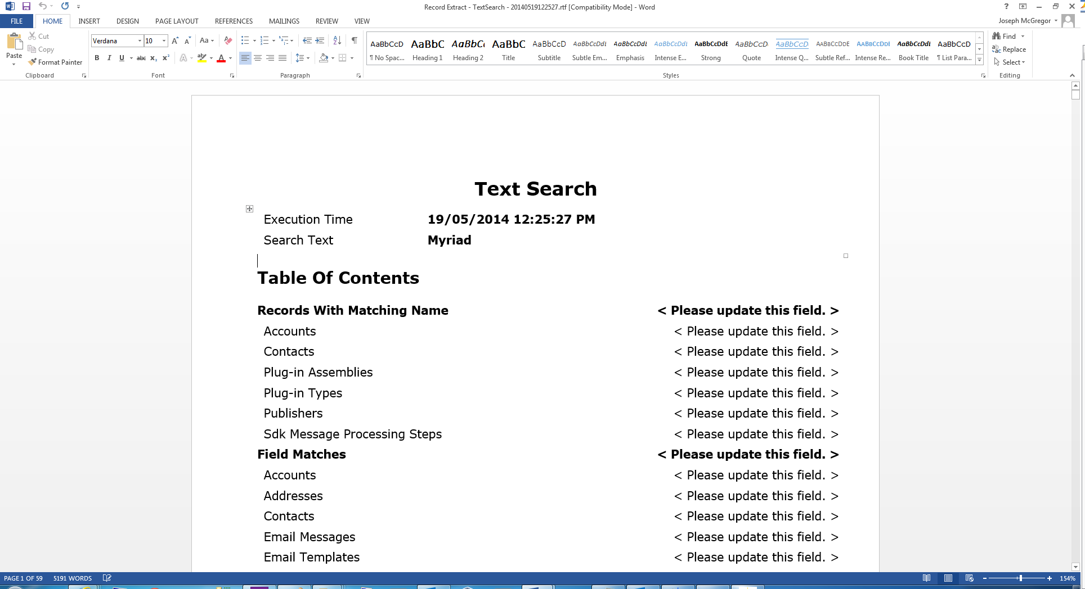

# Settings

There are several settings for the text search which can be configured by selecting “Text Search Settings” from the settings dropdown

These give the ability to

1. Configure the number of record per search set*
2. Exclude specific record types from the search
3. Exclude specific fields from the search
4. Set a field to search in sets*. This should be used if the application reports timeout errors when searching a text field

*the search sets were implemented for fields with a large volume of text. As the crm supported database access and web service does not allow indexing of full-text indexing of text fields where there is a large volume of text the application must iteratively search sets of records at a time so the web service/sql server does not timeout when searching through an excessive amount of text. An example of this is email content or note text which are configured by the system to always search in sets of records

